

Name: __________________

***Year 7 Biology 2020***

***Dichotomous Key Assessment Task***

1. Using the dichotomous key provided below, describe all the characteristics of: (3 marks)

½ deducted whenever a characteristic is missing

a) a mosquito ________________________________________________________

Insect with small or no wings, very long rear legs, antennae in the front of head

_________________________________________________________________________

b) a grasshopper _____________________________________________________

Insect with small or no wings, very long rear legs, antennae to the rear

_________________________________________________________________________

c) a termite soldier ____________________________________________________

Insect with small or no wings, shorter rear legs, not horned head, small eyes

_________________________________________________________________________

2. Modify the following list to reflect the levels of classification from the largest to the smallest group. (1 mark)

class, family, genus, kingdom, order, phylum, species

½ deducted whenever there is a ‘swap’ of two, or when one level is in the wrong place.

Kingdom, Phylum, Class, Order, Family, Genus, Species

______________________________________________________________________________________________________________________________________________

|  |  |  |  |  |  |  |  |  |  |  |  |  |  |  |  |  |  |  |  |  |  |  |  |  |  |  |  |  |  |  |
| --- | --- | --- | --- | --- | --- | --- | --- | --- | --- | --- | --- | --- | --- | --- | --- | --- | --- | --- | --- | --- | --- | --- | --- | --- | --- | --- | --- | --- | --- | --- |
| 3. Students created this key for their group. (1 mark)   |  |  |  | | --- | --- | --- | | 1a | male | go to 2 | | 1b | female | go to 5 | | 2a | straight hair | go to 3 | | 2b | curly hair | go to 4 | | 3a | can roll tongue | Mark | | 3b | cannot roll tongue | Yasu | | 4a | brown eyes | Hans | | 4b | grey eyes | Jack | | 5a | straight hair | Jane | | 5b | curly hair | Mai |   Provide a complete description of Jack;  ½ deducted whenever a characteristic is missing.  Male, with curly hair and grey eyes.  _________________________________________________________________________________________________________________________________________________________________________________________________________________________________ |

4. Complete the dichotomous key below (using the words from the boxes underneath) so that all of the animals can be identified. (3 marks)

**½ EACH**

5. Using the below pictures, complete the table to summarize the features of the eight striped animals. You will use this information to construct a dichotomous key. (8 marks)

**1 mark for each animal (each row).   
½ mark deducted every time a box in the row is wrong.**

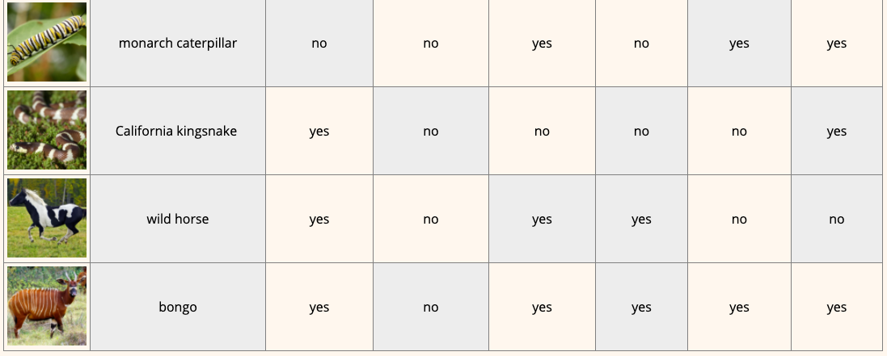

6. Create your branching dichotomous key on this page. Remember to give it a title.

(8 marks)

Title: _________________________________________________________________

**1 mark for each branch = 7 marks**

**plus 1 mark for Title**

Follow through any mistakes made on the table   
(eg. if they said lion-fish is not regularly striped, they lost a mark on the table, but not on the key).

7. According to the Classification chart below, which two organisms are most closely related? Explain why? (1 marks)

2 and 4 because they share the same **Family** and so are the closest.

____________________________________________________________________________________________________________________________________________________________________________________________________________________________________________________________________________________________________________________________________________________________________________________________

**END OF ASSESSMENT**

**TOTAL MARKS:__________/25**